Daniel Kim

Homework 3

1.

SELECT city, country

FROM customers

WHERE country = 'Australia'

ORDER BY city ASC;

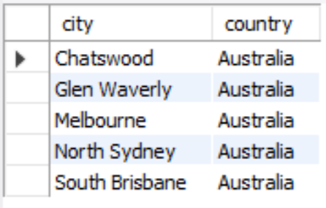

2.

SELECT employeeNumber, lastname, firstName, extension

FROM employees C, offices O

WHERE city = "Sydney" AND C.officeCode = O.officeCode;

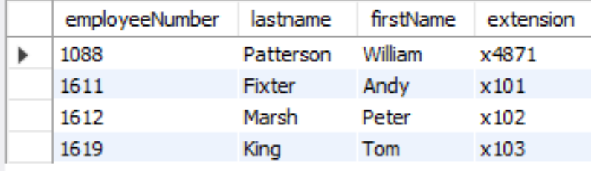

3.

SELECT productCode, productName, productVendor, quantityInStock, productLine

FROM products

WHERE quantityInStock BETWEEN 4000 AND 5000;

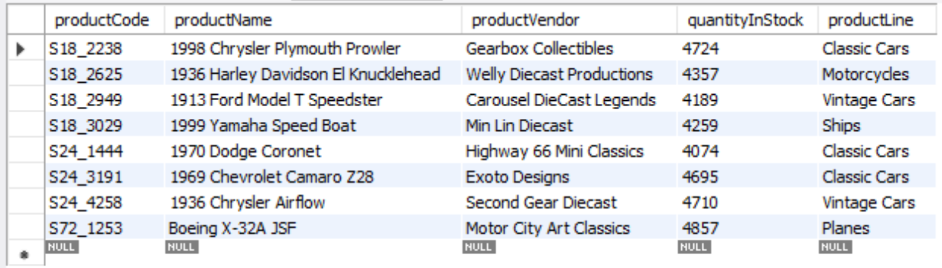

4.

SELECT ProductCode, ProductName, ProductVendor, BuyPrice, MSRP

FROM products

WHERE MSRP = (SELECT MAX(MSRP) FROM products);



5.

SELECT productName, MSRP, buyPrice, (MSRP - buyPrice) AS margin

FROM products

WHERE (MSRP - buyPrice) = (SELECT MIN((MSRP - buyPrice)) FROM products);

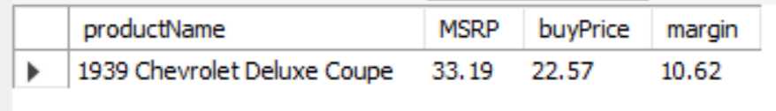

6.

SELECT country, Count(customerNumber) AS 'Customers'

FROM customers

GROUP BY country

HAVING COUNT(customerNumber) > 5

ORDER BY COUNT(customerNumber) DESC;

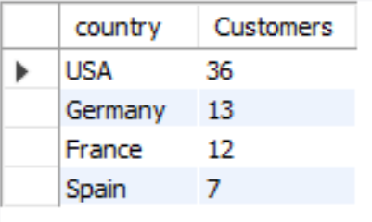

7.

SELECT C.productCode, C.productName, O.quantityOrdered AS OrderCount

FROM products C, orderDetails O

WHERE C.productCode = O.productCode

ORDER BY OrderCount DESC LIMIT 1;

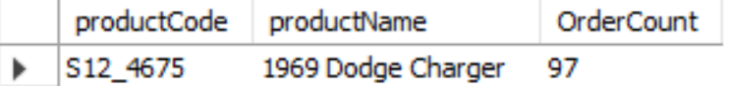

8.

SELECT CONCAT(m.firstname, ' ', m.lastName) as Manager, CONCAT(e.firstname, ' ', e.lastName) as Employee

FROM employees m, employees e

WHERE m.employeeNumber = e.reportsTo

ORDER BY m.firstname ASC;

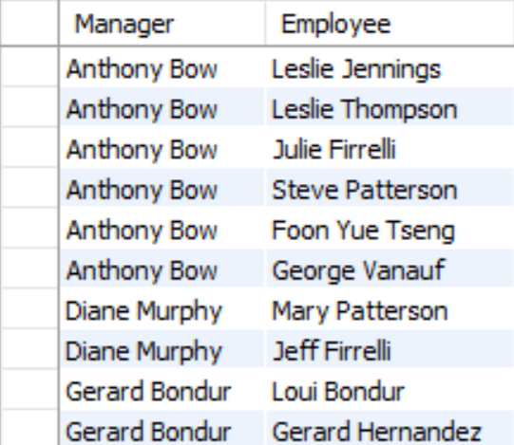

9.

SELECT CONCAT(m.firstname, ' ', m.lastName) as Manager, CONCAT(e.firstname, ' ', e.lastName) as Employee

FROM employees e

LEFT OUTER JOIN employees m ON e.reportsTo = m.employeeNumber

ORDER BY m.firstName ASC LIMIT 1;

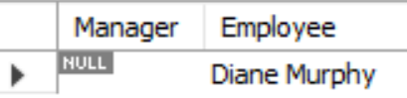

10.

SELECT productName

FROM products P

WHERE productLine = "Classic Cars"

AND substring_index(productName," ",1) BETWEEN 1960 AND 1969;

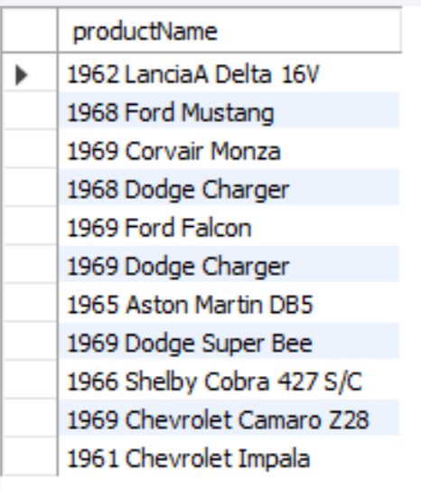

11.

SELECT MONTH(orderDate) AS Months, YEAR(orderDate) AS Years, COUNT(orderNumber) as Total

FROM orders

GROUP BY Months

ORDER BY Total DESC LIMIT 2;

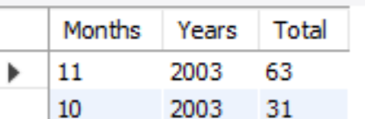

12.

SELECT employees.firstName, employees.lastName

FROM employees LEFT JOIN customers

ON employees.employeeNumber = customers.salesRepEmployeeNumber

WHERE jobTitle = "Sales Rep"

AND customers.salesRepEmployeeNumber IS NULL;

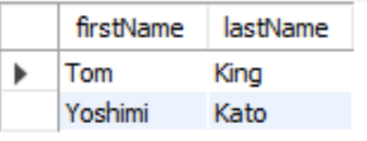

13.

SELECT customers.customerName

FROM customers LEFT JOIN orders ON customers.customerNumber = orders.customerNumber

WHERE country = "Switzerland"

AND orders.customerNumber IS NULL;

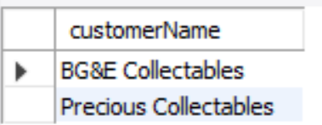

14.

SELECT customerName, SUM(quantityOrdered) as Total

FROM customers C, orders O, orderdetails OD

WHERE (C.customerNumber = O.customerNumber AND O.orderNumber = OD.orderNumber)

GROUP BY customerName

HAVING (Total < 500);

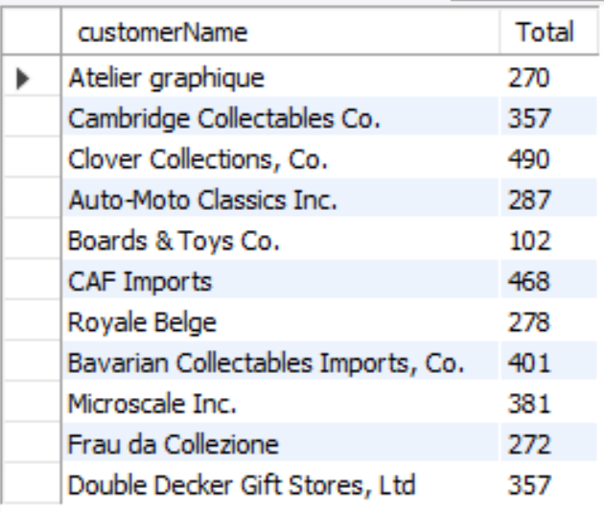

15.

CREATE TABLE LowCustomers

(CustomerNumber int NOT NULL, ContactDate DATE NOT NULL,

OrderTotal decimal(9,2) NOT NULL,

OrderTotal decimal(9,2) NOT NULL,

CONSTRAINT LowCustomer_PK primary key(CustomerNumber));

16.

INSERT INTO LowCustomers(CustomerNumber,ContactDate,OrderTotal)

SELECT c.CustomerNumber, curdate(), SUM(priceEach*quantityOrdered) AS Total

FROM customers C, orders O, orderdetails OD

WHERE (C.customerNumber = O.customerNumber AND O.orderNumber = OD.orderNumber)

GROUP BY customerNumber

HAVING Total < 50000;

17.

SELECT *

FROM LowCustomers

ORDER BY orderTotal DESC;

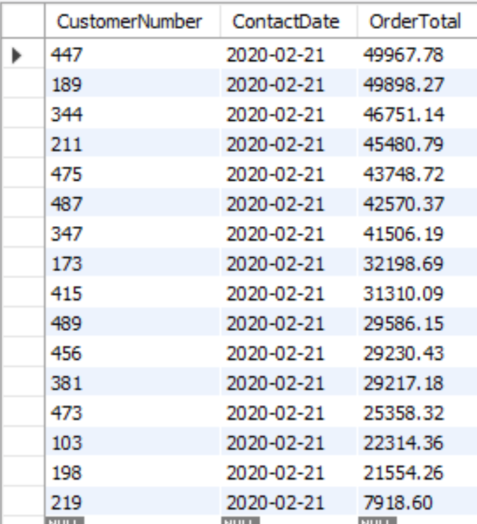

18.

ALTER TABLE LowCustomers

ADD OrderCount INT NOT NULL;

19.

UPDATE LowCustomers

SET OrderCount = FLOOR(RAND()*(18-0)+0);

20.

SELECT *

FROM LowCustomers

ORDER BY orderCount DESC;

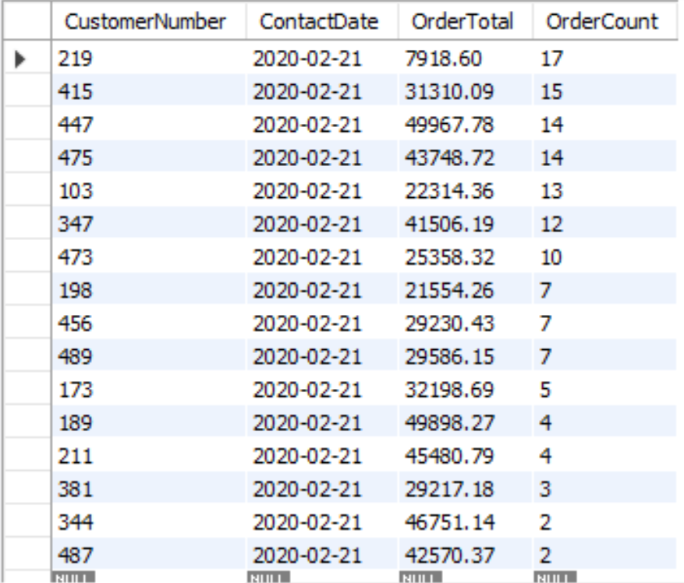

21.

DROP TABLE LowCustomers;